ASN (Autonomous System Number)

🌐 What Is ASN (Autonomous System Number)?
# Source: Chatgpt (GPT‑5 Mini) at [12/15/2025]
An ASN (Autonomous System Number) is a unique identifier assigned to an Autonomous System (AS) — a collection of IP networks under a single administrative domain that shares a common routing policy, especially when using BGP (Border Gateway Protocol) for routing on the internet.

🧠 Simple Definition:
# Source: Chatgpt (GPT‑5 Mini) at [12/15/2025]
An ASN is like a license plate for networks — it identifies who owns and controls a group of IP addresses that are routed together on the internet.

📦 Why ASN Matters
# Source: Chatgpt (GPT‑5 Mini) at [12/15/2025]
- ASNs let routers know where traffic is coming from or going to across the internet.
- They help with path selection and routing decisions in BGP.
- They are globally unique and assigned by Regional Internet Registries (RIRs) such as:
  - ARIN (North America)
  - RIPE NCC (Europe)
  - APNIC (Asia-Pacific)
  - AFRINIC (Africa)
  - LACNIC (Latin America)

🔢 Types of ASN
# Source: Chatgpt (GPT‑5 Mini) at [12/15/2025]
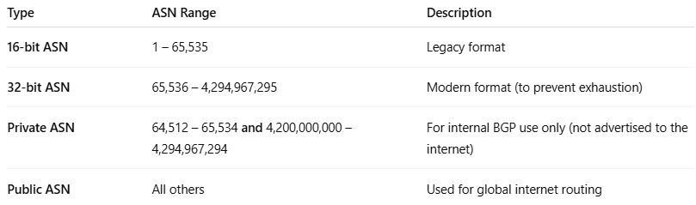

Type | ASN Range | Description
16-bit ASN | 1 – 65,535 | Legacy format
32-bit ASN | 65,536 – 4,294,967,295 | Modern format (to prevent exhaustion)
Private ASN | 64,512 – 65,534 and 4,200,000,000 – 4,294,967,294 | For internal BGP use only (not advertised to the internet)
Public ASN | All others | Used for global internet routing

🏢 Example: ASN in the Real World
# Source: Chatgpt (GPT‑5 Mini) at [12/15/2025]
- Google owns AS15169
- Cloudflare owns AS13335
- Facebook (Meta) owns AS32934
When routers exchange BGP updates, they use ASNs to build the AS path, which tells routers how traffic should flow across networks.

🗺️ Example: AS Path Using ASN
# Source: Chatgpt (GPT‑5 Mini) at [12/15/2025]
Let’s say you're trying to reach Facebook:
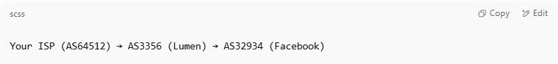
Your ISP (AS64512) → AS3356 (Lumen) → AS32934 (Facebook)

The AS path is:
64512 → 3356 → 32934

✅ Summary
# Source: Chatgpt (GPT‑5 Mini) at [12/15/2025]
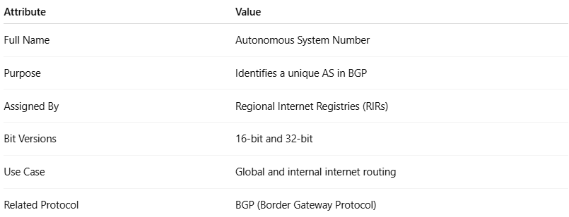

Attribute | Value
Full Name | Autonomous System Number
Purpose | Identifies a unique AS in BGP
Assigned By | Regional Internet Registries (RIRs)
Bit Versions | 16-bit and 32-bit
Use Case | Global and internal internet routing
Related Protocol | BGP (Border Gateway Protocol)

